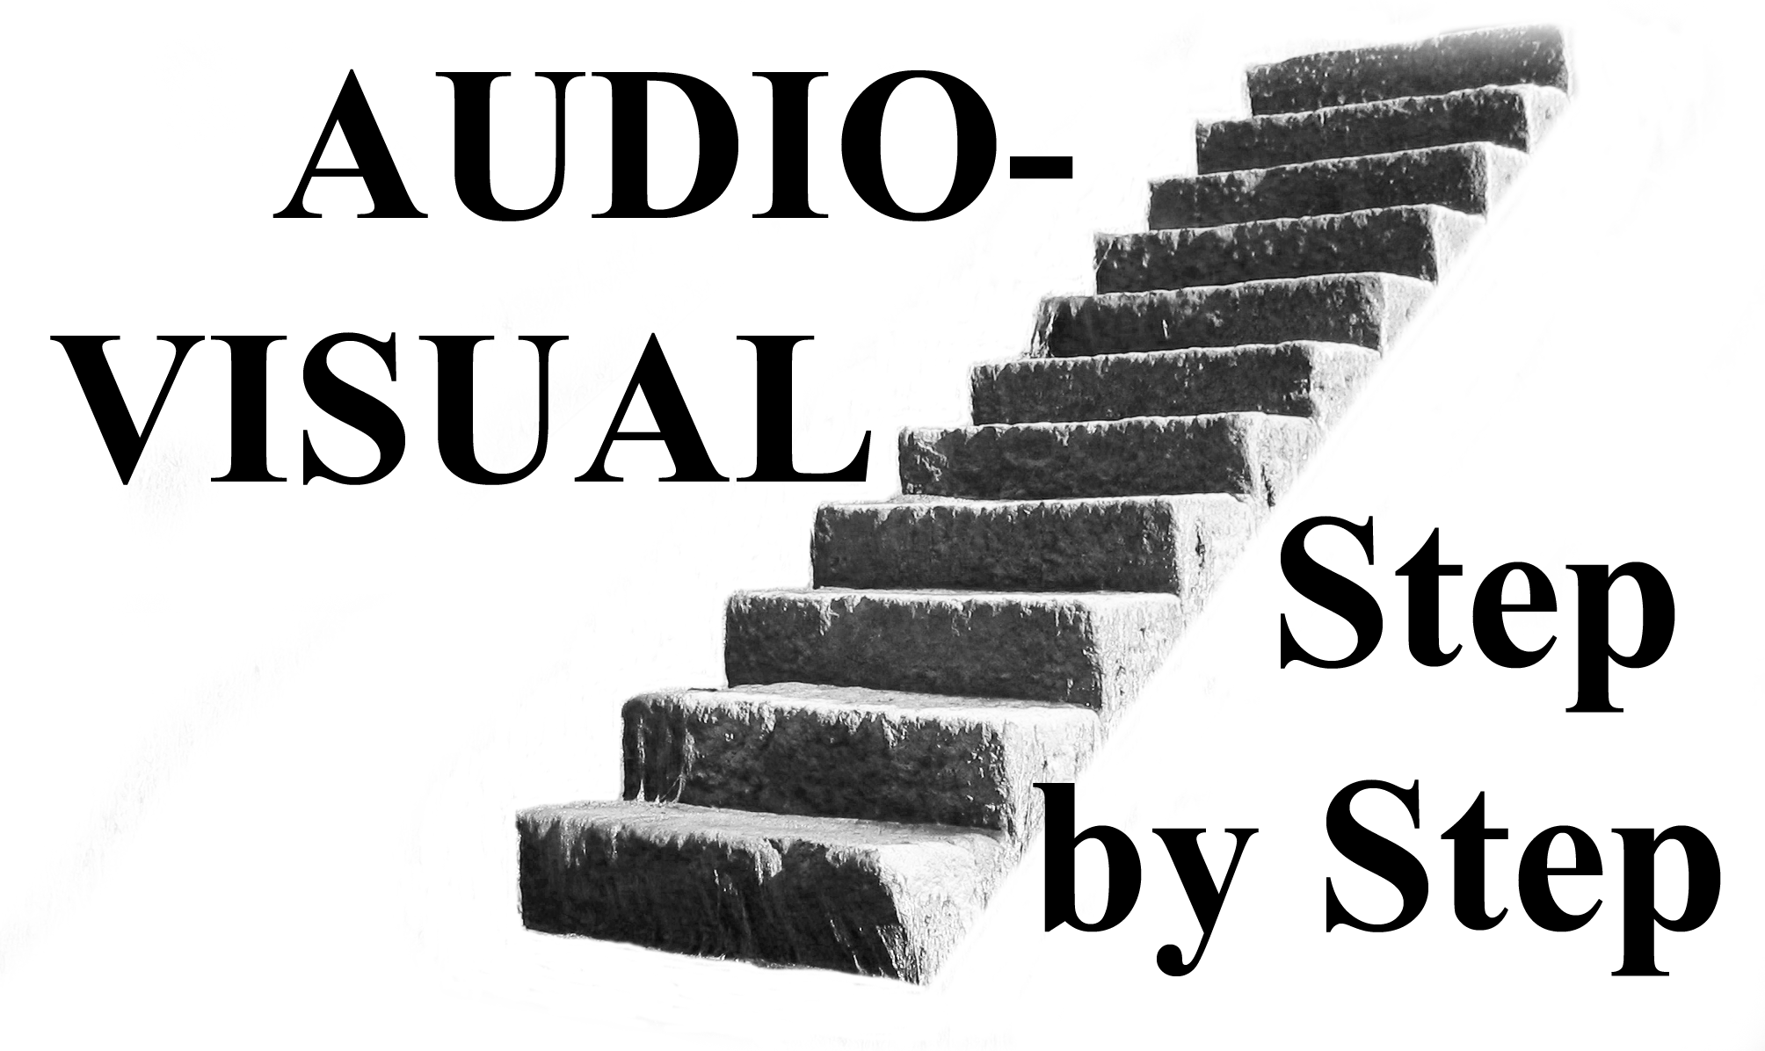

A tutorial CD-ROM
by Howard Gregory

Most people start in audio-visual as “an interesting way to show their pictures.” It can be very effective when used in this way, but that is only the beginning. A-V is capable of doing so much more.

This CD explains, step by step, from the absolute beginning, with the aid of diagrams, screen-grabs, worked examples etc, how to get started in this fascinating hobby. In a couple of evenings you could be making simple pictures-to-music sequences. Advice is given on how to develop and improve them to make them as satisfying as possible to the audience. We hope, however, that you will wish to progress beyond that to more elaborate productions. Further step by step advice is given about more advanced techniques which will help you to lift your work above the ordinary. If you keep an open mind, you will never stop learning about A-V, and suggestions are made as to how and where to gain even more information. With today’s technology the only limits are your imagination, your creativity, your expertise and, maybe, your patience.
The bulk of the CD is in the form of a CD-ROM - it’s a bit like having me sit down at your computer and take you, step by step, through all you need to know. You can pause or go back to listen to a bit again at any time.

In addition to the tutorials, there are documents giving supporting information.

Total running time of the tutorials is 154 minutes, with the story broken down into 14 bite-sized sections. If your system will play .exe file A-V sequences, this CD will run.

The cost is £12 plus £1 p&p (for one CD) and can be obtained from Howard Gregory, 64 Mill Lane, Heatley, Lymm, Cheshire, WA13 9SQ. Phone 01925 75 3303.
e-mail chairman@wilmslowguildav.org.uk

Also available:

“Audible photography” - showing how your familiarity with photographic processes can be transferred to the equivalent audio processes.

“Better Soundtracks” – how to make professional-sounding soundtracks on an ordinary domestic computer.

"All About Microphones" – everything you need to know to choose and use a mic. There's a lot about recorders and camcorder audio too.

"Understanding Audio” – helping you to get a “feel” for audio so that you get things right first time. A lot about speakers too.

Sound effects CDs, audio guides, mic preamps, special leads etc.

Please ask (preferably by e-mail) for detailed leaflets.

Howard and Suzanne also give talks to interested photographic societies, video and audio-visual groups.

